**OpenEdge Upgrade Document**  
  
This document provides a comprehensive guide for upgrading the OpenEdge environment to the latest stable version, ensuring improved performance, enhanced security, and access to the newest features. The upgrade process outlined in this documentation is designed to minimize downtime and ensure a seamless transition while maintaining the integrity of existing systems and data.

The steps include pre-upgrade preparations, the detailed upgrade procedure, and post-upgrade validations, along with troubleshooting tips to resolve potential issues. This guide is intended for system administrators, database administrators (DBAs), and technical engineers involved in maintaining and upgrading the OpenEdge ecosystem.  
  
**Prerequisites** -  
Understanding on OpenEdge installation  
REA request of upgrade from Support or Professional Services  
OpenEdge approval request against uplift

**Request of OpenEdge Service Pack uplift**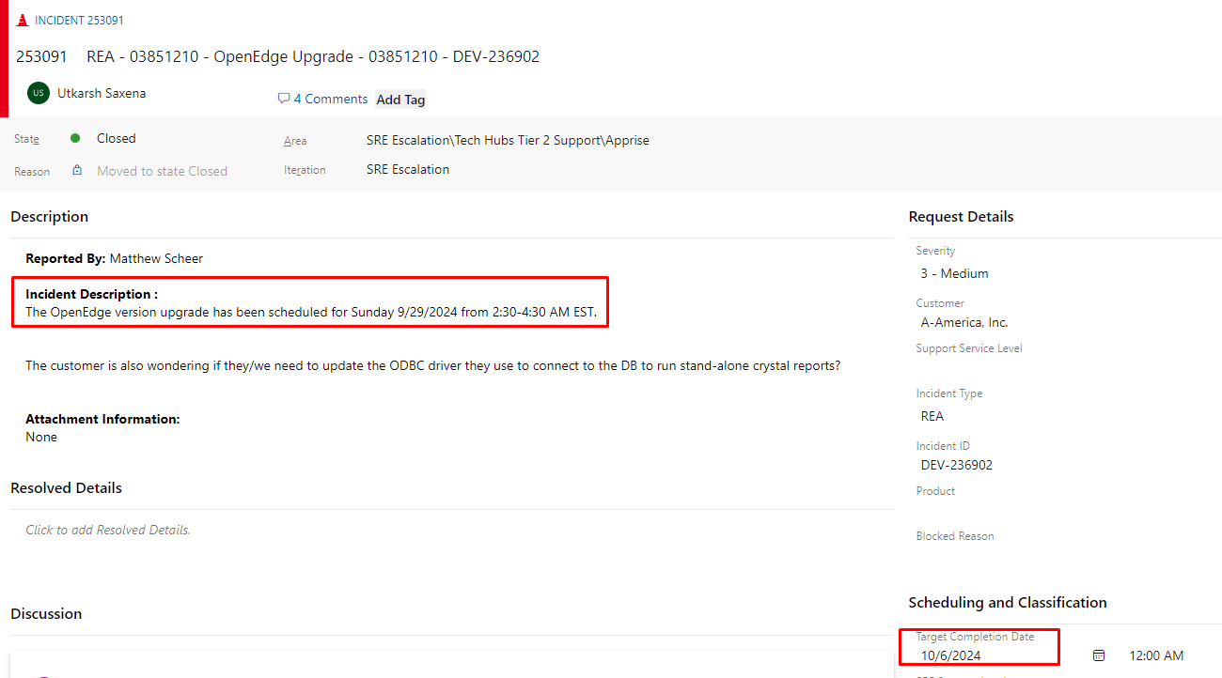

**ServiceDesk Approval Request** -  
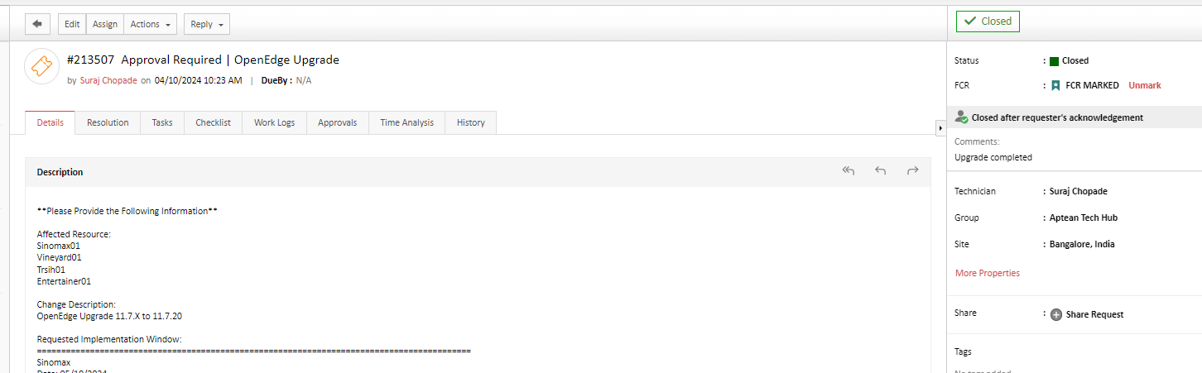

Steps to follow –

1. Collect the zip file of upgrade version from R&D or Professional Services and place it to server where upgrade is going to take place.
2. Extract the zip file and backup the properties folder from original DLC path

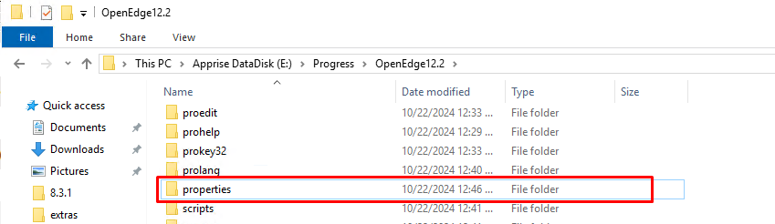

1. Change start type of OpenEdge services and Application related serviced to “manual”, restart server.
2. Log back in server and from extracted folder run the setup.exe file as administrator

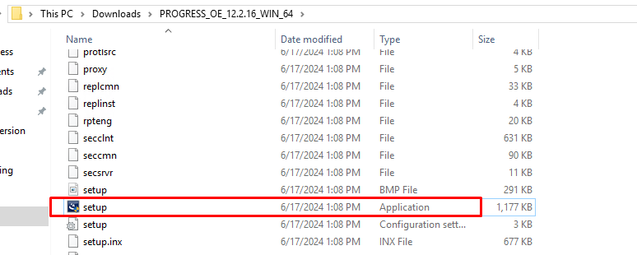

1. This will start installing the new version

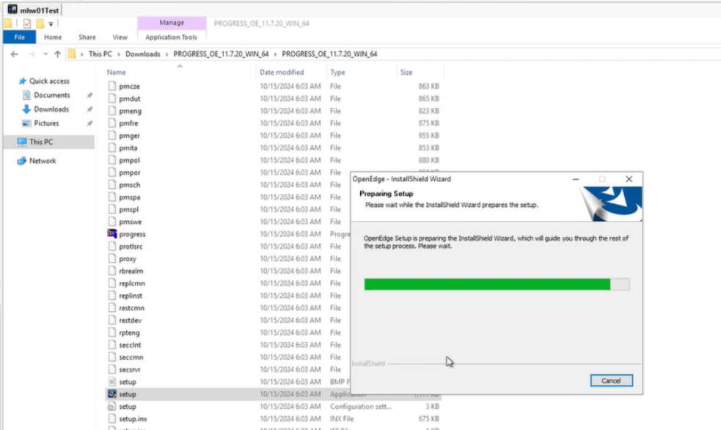

1. This will start checking OpenEdge processes that are active and if no active process found it will start installation and click NEXT.

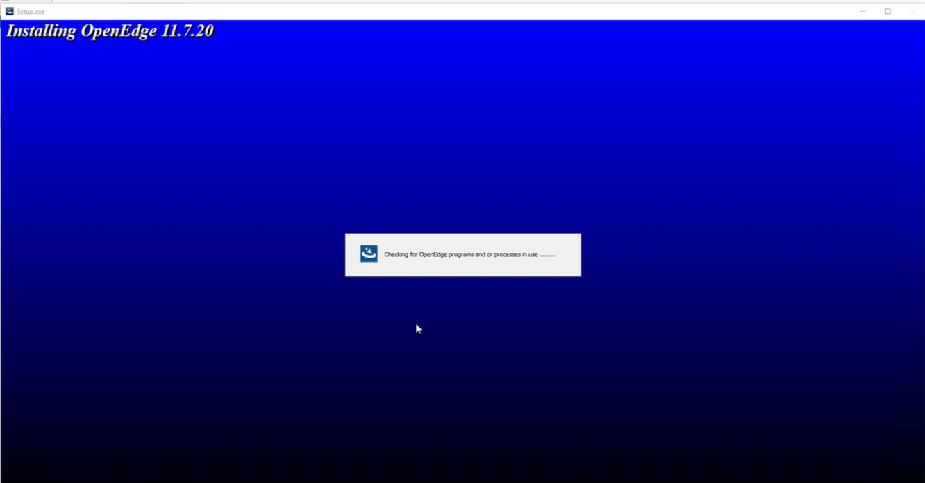

1. A screen will pop up for selecting the path of backing up the properties files and click NEXT.

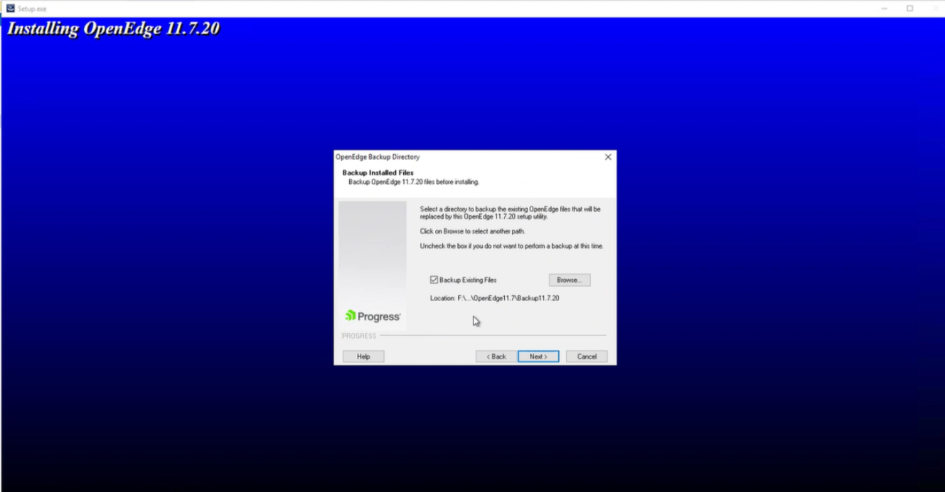

1. Next screen will show the update summery and click NEXT

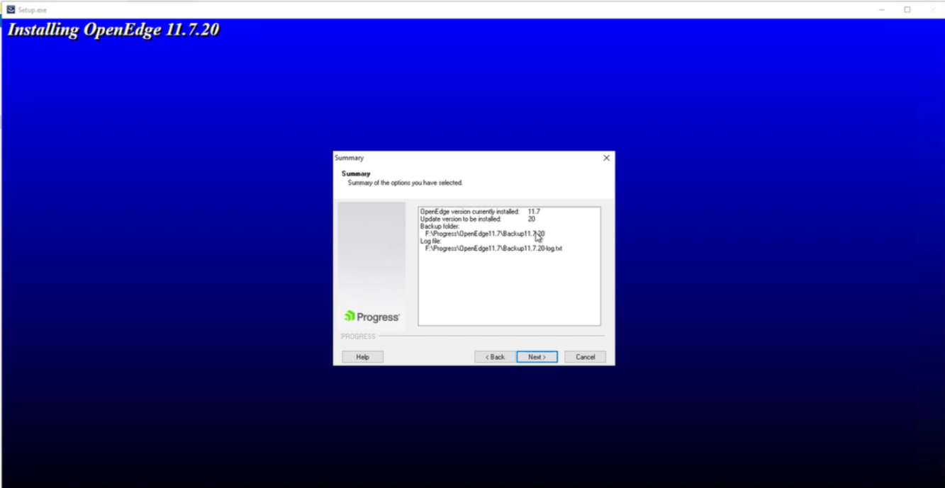

1. OpenEdge upgrade install progress will show

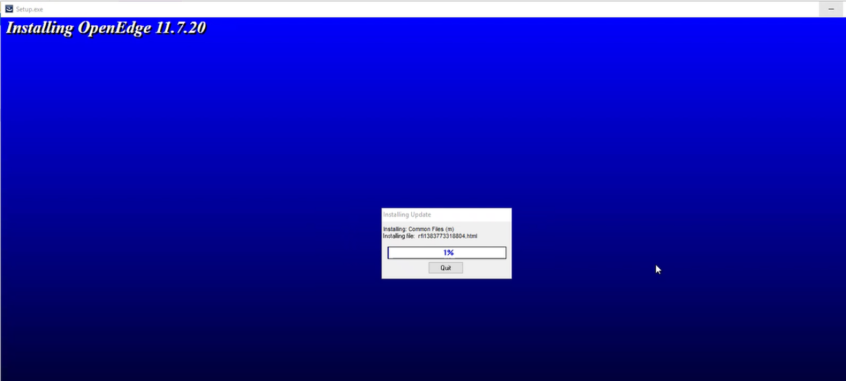

1. Post install upgrade is completed OpenEdge upgrade will start.

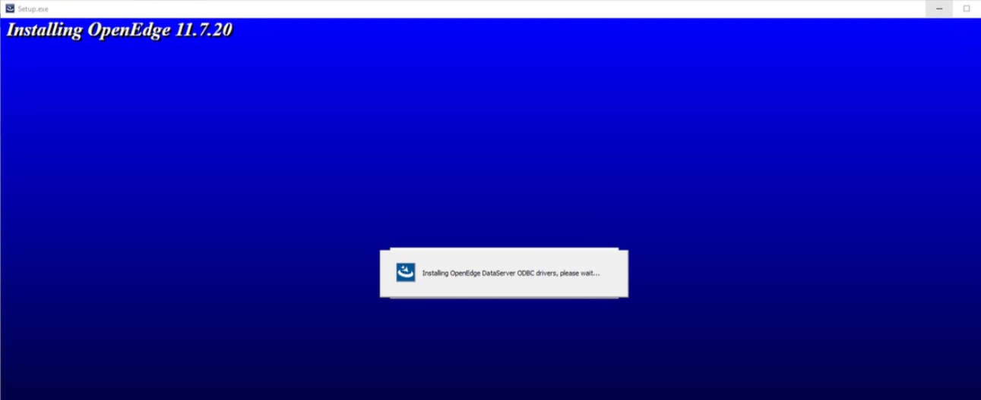

1. Once upgrade is completed, proceed with changing all the OpenEdge and application SA related services start type to automatic and reboot the server.